April 2017 Newsletter – Institute of Grace
Happy Easter!
As I write on Easter Day, I depart tomorrow for my April session with the Universite de la Grace students. This is the second of six sessions scheduled this year. May 22-30 I will be offering the third session and Kent Hills will be coming with to work on our trucks and the possibility of solar power for our electrical needs. June 21-28 a team from the Church of the Redeemer will be working with the youth and the Universite. With the Guest House up and running we are ready for individuals and teams to visit.
I also have trips scheduled for September 12-20 and November 7-16 so there are more opportunities to come along.
The picture below is of Steven instructing some of the school children. Because of the computer lab, they are able to offer classes in computers to the children. Steven is also one of our University students.
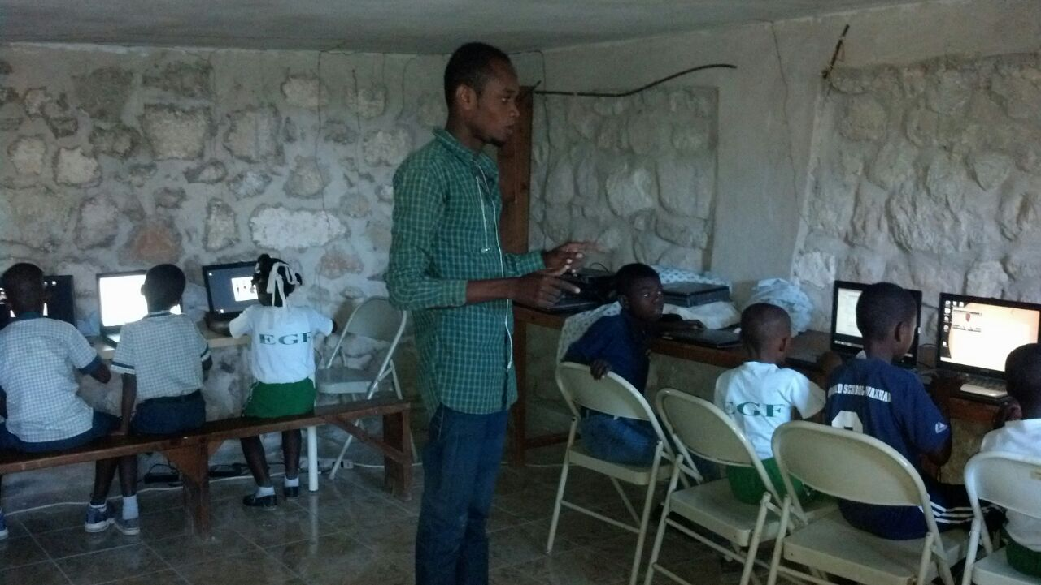
Steven working with some of the school children in the computer lab.

The school year continues until June for the children and they are blessed by the support the IOG is able to send. We are thankful for the donations that make it possible to provide school for them.
Contributions can be mailed to: [we also have an online giving option on the IOG website]
Institute of Grace [InstituteofGrace.org]
P.O. Box 2364
Leesburg, VA 20176 Christ is Risen!
David Graves April 16, 2017

